1. ***Subject area description.***

Summer Olympic Games is sport event that is held every four years in different cities. First Olympic Games were held in 1896 in Athens, Greece. There are 42 different Olympic sports (Archery, Athletics, Aquatics, Gymnastics, Wrestling, Boxing, Rowing, etc.) that include 55 different disciplines (for example, Athletics include Gymnastics includes Artistic G., Rhythmic G. and Trampoline). In all these 55 discipline there are over 650 events (for example, Swimming includes 100m butterfly, marathon 10km, 800m freestyle, 200m breaststroke, etc.). Sportsmen (men and women) from more than 140 countries take part in Olympic Games every year. Winners in every kind of sport get medals (gold, silver, bronze). If their results better than existing Olympic and world records such results announced to be new records.

1. ***Tables description***

|  |  |  |
| --- | --- | --- |
| Table | Field | Description |
| **DIMENSION TABLES** | | |
| **sportsmen** (for storing data about athletes) | sport_id | PK |
| athlete | Sportsmen’s name |
| gender | Sportsmen’s gender |
| **events** (for storing different kinds of events) | id | PK |
| event | Kind of event |
| **sport_disc** (for storing kinds of sport, appropriate disciplines and events) | id | PK |
| sport | Kind of sport |
| discipline | Discipline corresponding kind of sport |
| event_id | FK to table **events** |
| **records** (for storing types of recoreds) | id | PK |
| type | Record type (Olympic or World) |
| **olympic_games** (for storing data about Olympic games (OG) location) | No | PK (number of OG) |
| City | City, where OG were held |
| Country | Country, where OG were held |
| Year | Year, when OG were held |
| **countries** (for storing data about sportsmen’s countries) | Country_id | PK |
| Country_code | Countries’ codes according to national Olympic committee |
| Country_name | Countries’ name |
| Note | Past nation – country or group of countries that doesn’t exist nowadays |
| **category** (for storing data about event categories) | Id | PK |
| Event_category | Men, women or team |
| **FACT TABLE** | | |
| **results** (for storing data about sportsmen’s results) | Id | PK |
| Olympiada_id | FK to appropriate tables |
| Sport_disc_id |
| Sportsman_id |
| Country_id |
| Category_id |
| Record_id |
| Place (**fact**) | Number of place, that was taken by sportsman in appropriate kind of sport |

**Olympic_games table**

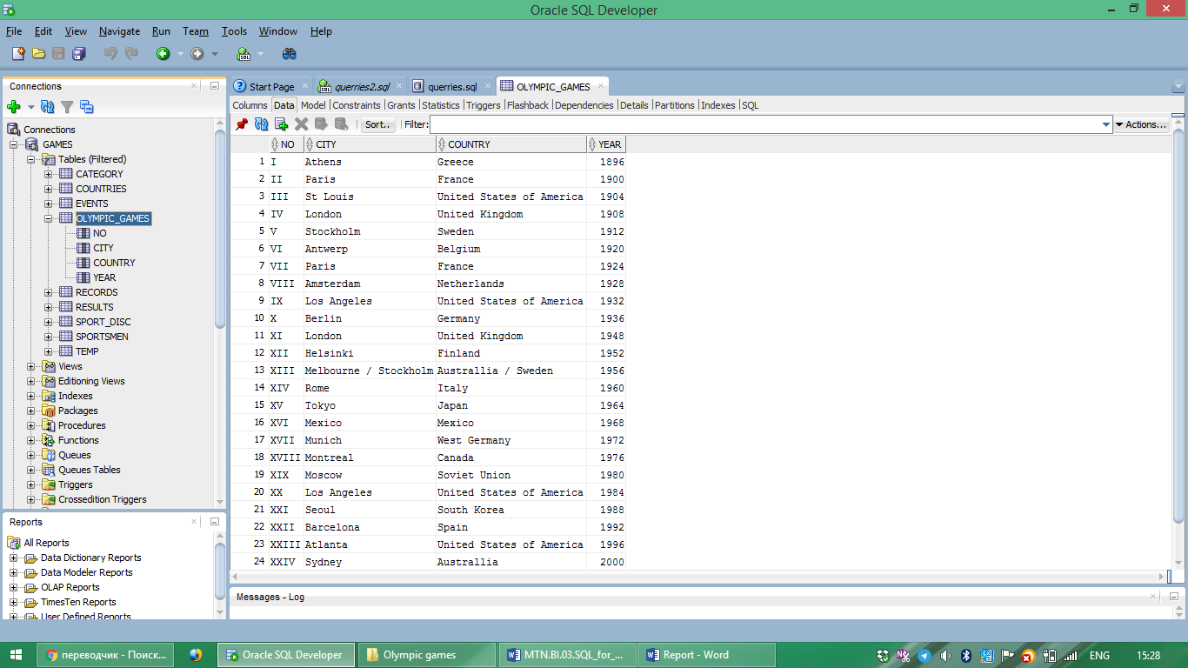

**Events table**

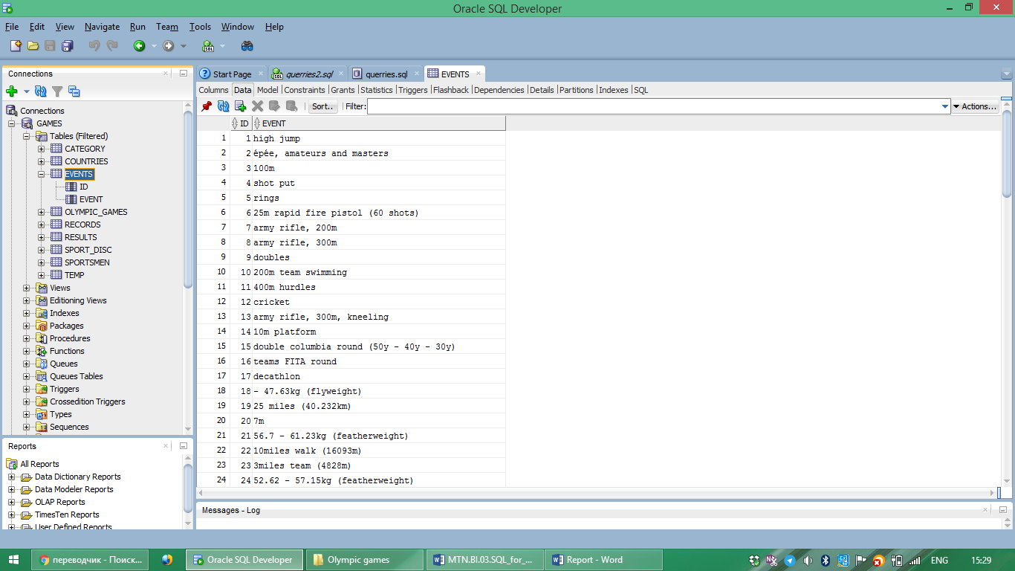

**Sport_disc table**

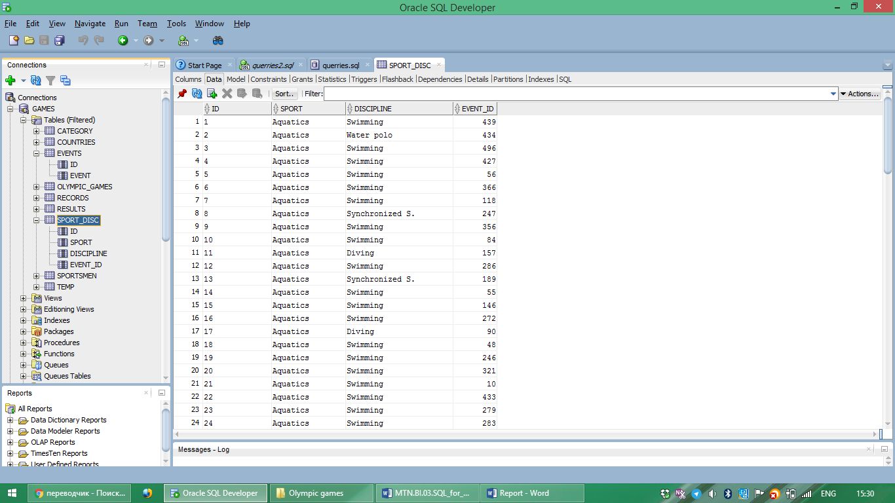

**Countries table**

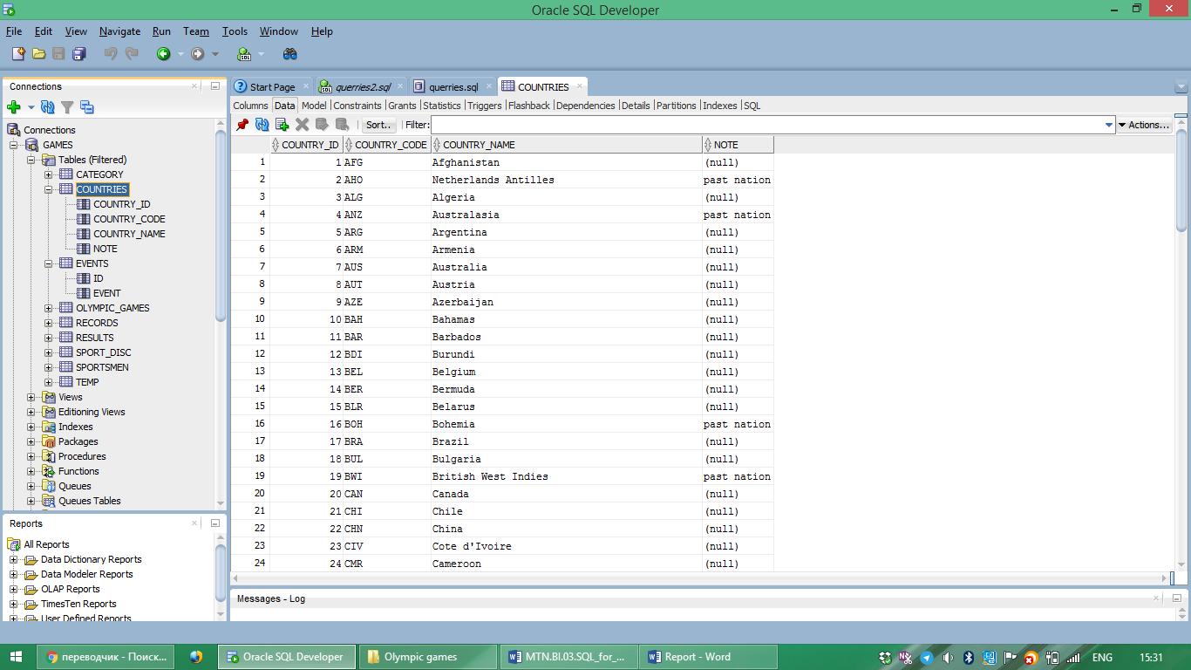

**Sportsmen table**

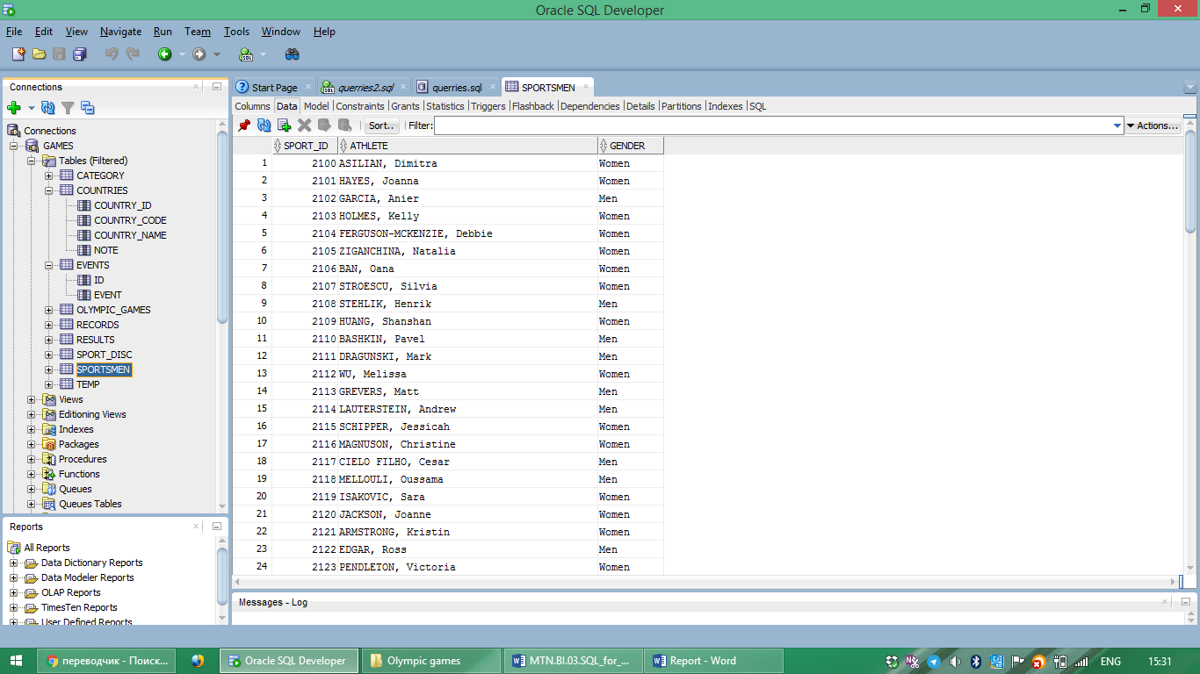

**Result table**

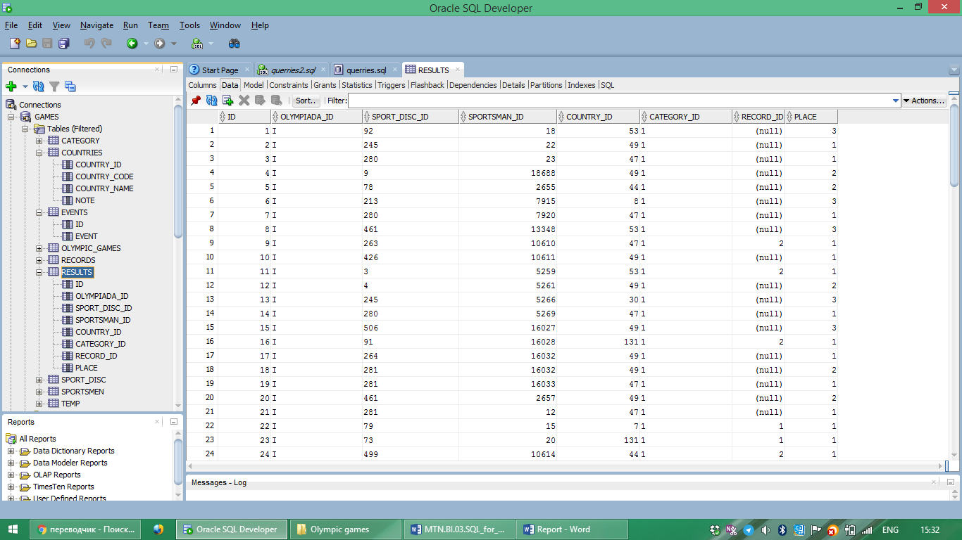

1. ***Schema***

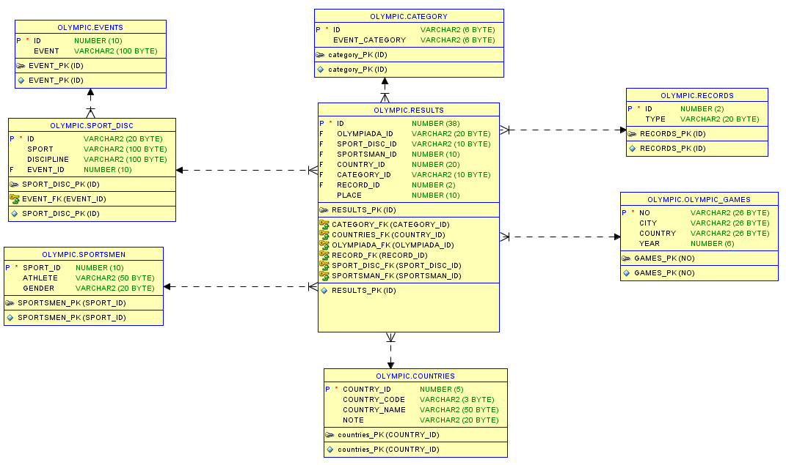

1. ***Reports***
2. Top-3 disciplines with bigger amount of records in each category (Olympic records and World record).

**The result is:** Athletics, Rowing and Swimming are top-3 disciplines in which there the biggest number of Olympic and World records.

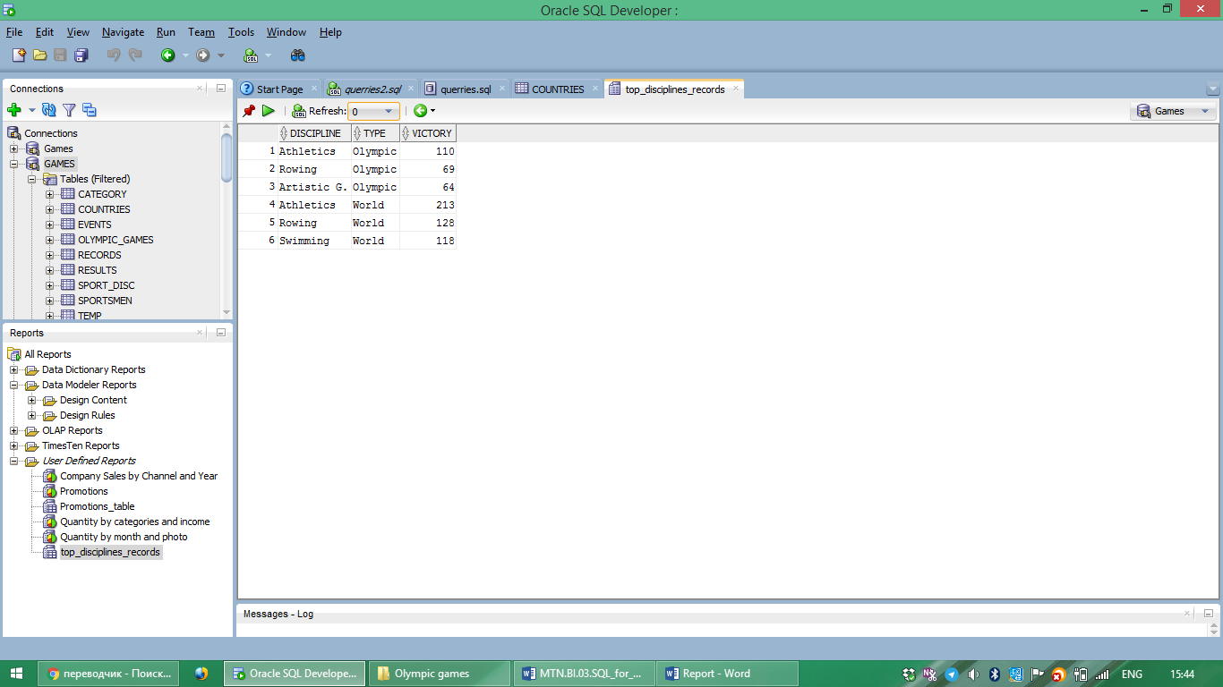

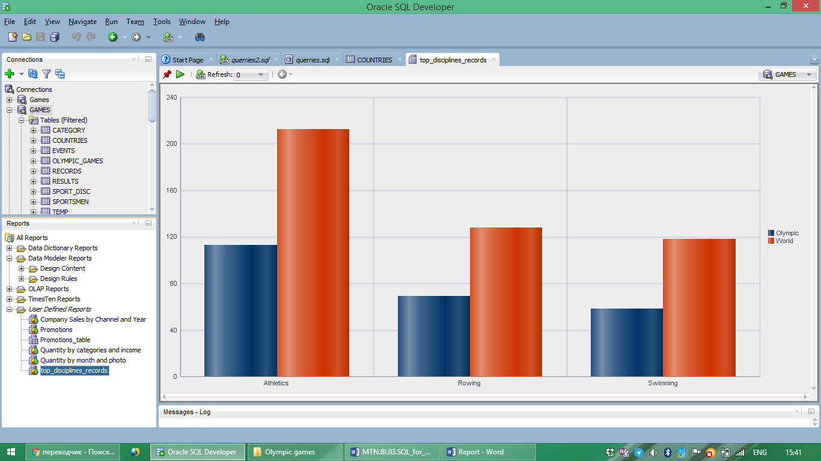

1. Top-5 athletes and their appropriate kinds of sport that got the biggest number of medals in whole history of Olympic Games (report in xsl – **top_athlete.xsl**).
2. The amount and percent of medals that were got by sportsmen from USA and Soviet Union.

**The result is:** sportsmen from Soviet Union almost every year got more medals.

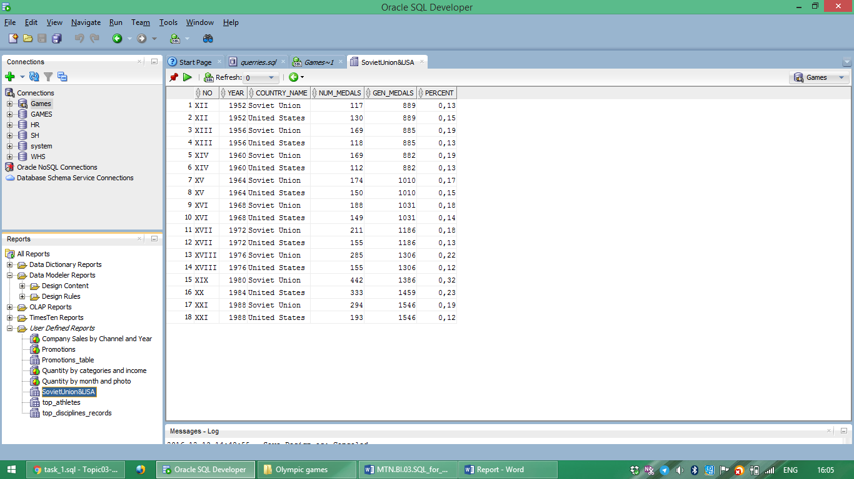

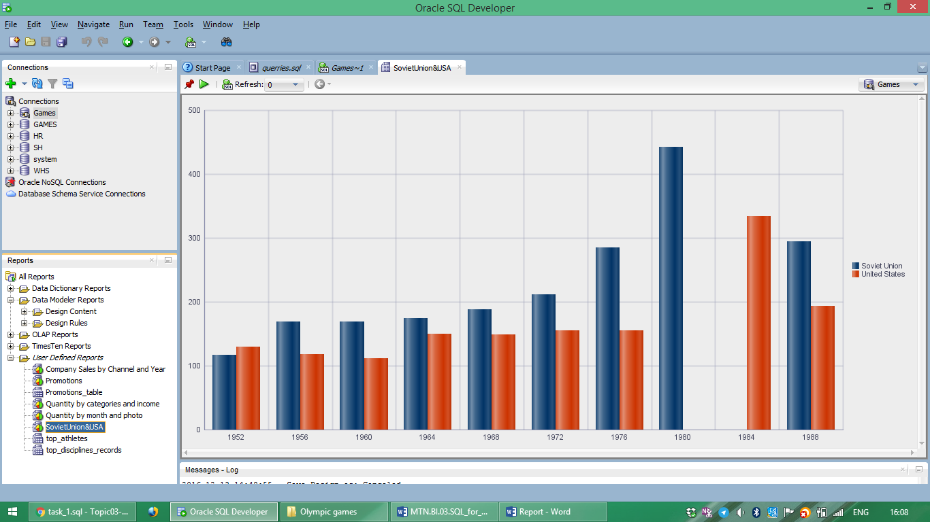

1. Countries that have the biggest amount of medals in each kind of team sport like football, volleyball, basketball, etc.

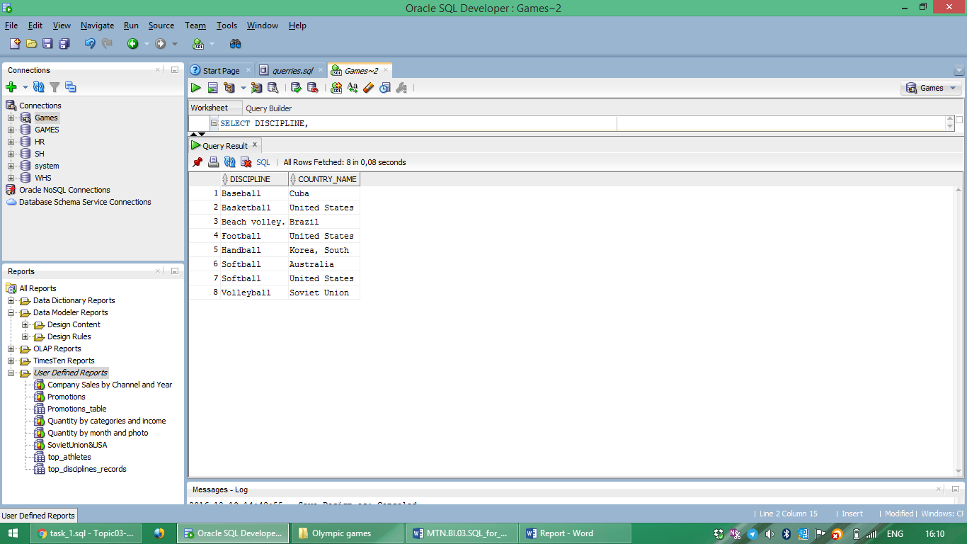

1. The list of top-3 disciplines in which sportsmen were successful. Such list was generated for each country. (The report in pdf – **disciplines_list**.pdf).
2. The amount of medals in such sport as Boxing, Wrestling, Taekwondo that got men and women.

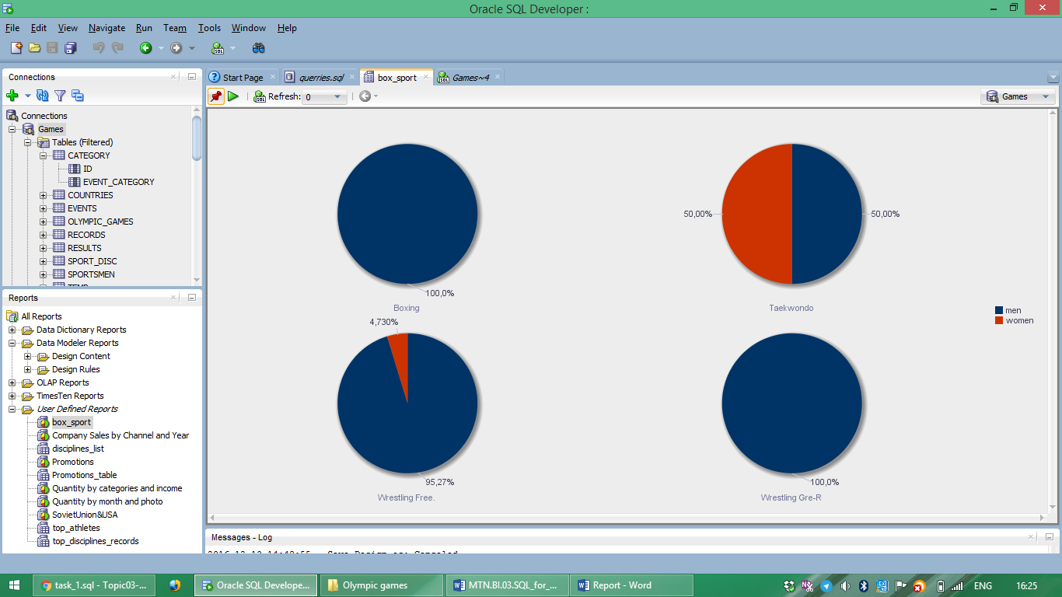

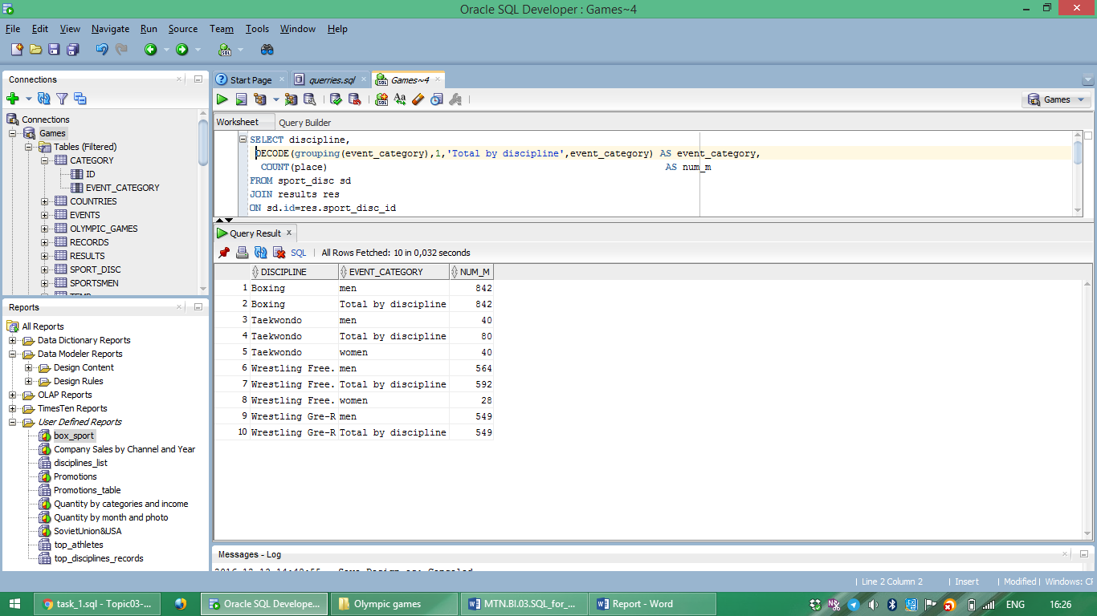

1. Countries that have been in top-10 in medal standings for recent 20 years (their were in top-10 during last 5-6 Olympic Games)

